Hyper Technology Proposal



Table of Contents

1.0 | Executive Summary ……………………………………………3
 | 1.1 | Objectives …………………………………………………………………………………………3
 | 1.2 | Mission ……………………………………………………………………………………………...4
 | 1.3 | Keys to Success ………………………………………………………………………..……….4
2.0 | Company Summary …………………………………………....4
3.0 | Market Analysis ………………………………………………..6
 | 3.1 | Market Trends ……………………………………………………………………………….….6
 | 3.2 | Target Market …………………………………………………………………………………..6
4.0 | Competitive Analysis …………………………………………..7
 | 4.1 | Competitors ……………………………………………………………………………………..7
 | 4.2 | Competitive Advantage ………………………………………………………………….…7
5.0 | Strategy Analysis …………………………………………….…8
 | 5.1 | Marketing Strategy …………………………………………………………………………...8
 | 5.2 | Sales strategy ………………………………………………………………………………..…..9
 | 5.3 | Pricing Strategy ………………………………………………………………………….…..….9
6.0 | Financial Model …………………….……………………….…11
7.0 | Business Model Canvas ……….………………………………..12

1.0 Executive Summary

There are 360 million persons in the world with disabling hearing loss (5.3% of the world’s population) and 328 million (91%)of these are adults (183 million males, 145 million females). From 2.72% up to 4.41% of the whole percentage are located in developing countries (including Egypt).

The impact of hearing impairment on the individual and society is significant. Development of hearing loss leads to severe handicap that affects the sufferer’s job, home and life with subsequent social and economic burden on the society.

The price of good to high quality hearing aids in Egypt varies from 2500 to 20000 pounds as an average. It depends on the power of the device, type, number of channels, and the level of the used technology.

There is such a huge potential in that market (Egypt) as we intend to design a high quality hearing aid with a lower price. We will mainly depend on e-marketing and social networks. We will target the adult and old people (aged from 30 to 65). Our main components are a microphone, a speaker, a microcontroller and a battery. The best competitive advantages will be represented in our lower prices and using a mobile app to control the hearing aid.

Management

Hyper Technology will be led by two engineering students on a high level of creativity with enough experience in embedded systems and great business skills. Sales forecasts indicate that Hyper Technology will achieve sterling sales for next year and Net profit will be untarnished.

1.1 Objectives

Design and implement financial controls to help ensure success and achieve profitability.
Our objective is 2 products :
First : is mainly a mobile app that helps hearing impaired persons to amplify the frequencies they don’t hear well

Second : is a complete standalone headset that works as a Digital Hearing Aid and controllable by a mobile app via Bluetooth

1.2 Mission

Our mission is to offer customers the best product and the best price. Customer’s expectations will always be exceeded.

1.3 Keys to Success

Employ careful financial analysis to ensure efficiency and exceed customer expectations by offering high quality products at reasonable prices and quick turnaround time.

2.0 Company Summary

Hyper Technology is a start-up organization formed by two engineering students.

Hyper Technology will incur the following expenses for start-up:

- Marketing department (1 teams with 3 employees):

They will be responsible of online marketing and social media.

- R&D department (1 team with 5 employees):

They will be responsible of designing and developing our hearing aid and the mobile app.

- Financial department (1 team with 3 employees):

They will build our financial analysis and ensure that the financial plan is suitable our resources to gain maximum profits.

- HR department (1 team with 3 employees):

This department will ensure using the whole resources of the company.

The company will be organic in its structure in the first year then it will tend to be mechanic. That means in every project the supervisor will be randomly selected from each team. The HR department will be constructed within five months.

The components of the hearing aid are:

- Microphone and Amplifier:
Every hearing aid has a microphone that picks up sound and sends it to the amplifier.

- Ear Hook:
It’s important to make sure the ear hook fits snugly, but not uncomfortably, on your ear and that it’s connected securely to the casing and tubing.

- Connecting Tubing:
The plastic tubing that fits onto the end of the hear hook transmits the electronic sound from the microphone into the ear mold.

- Earmold:
These form-fitting plastic or acrylic components fit snugly inside your ear canal and concha bowl (the outer ear closest to your ear canal) to provide an acoustic seal for the electronic sound your microphone is piping inside.

- Dspic33f:
The features (Up to 70 MIPS DSC at 3.3V-Single cycle 16 x 16 MAC-Integrated Op Amps-40-bit accumulators and dual operand fetches -Fast DMA with no cycle stealing -Highly integrated motor control, SMPS and audio peripherals).

- The mobile app:
It is consisted of a simple design that is suitable for controlling many frequencies with a fine range of specific gains for amplification and noise cancellation.

https://www.yourhearing.co.uk/hearing-aids
this link has a price list that contains the best companies with the brands of their hearing aids and some details about these brands.
The range of these products is from 500£ to 2000£.

3.0 Market Analysis

3.1 Market Trends

There will be a 2-4% yearly unit growth driven by demographic development. According to many researches, there is +10% of population in Egypt suffer from hearing disabilities (more than 3 million people), 35-40% of population aged +65 are hearing –impaired, and Just above 20% of the hearing impaired use a hearing aid.
The drivers for increased penetration are:
- Increasing age and gross domestic product (GDP).
- Next 65+ generation is wealthier.
- Developing markets are significantly underpenetrated.
- Ability to access to great distribution.

3.2 Target market

Our target market will be the people who are aged +30 as they represent more than 2 million people in Egypt.

4.0 Competitive Analysis

4.1 Competitors

Hyper Technology has identified three competitors:

- Hansaton:

Hansaton carries a full range of hearing solutions. They produce digital hearing aids with award-winning designs, with features such as feedback blocking, speech direction adjustment, and high fidelity sound listening capability.

- Phonak:

Phonak has a complete portfolio of hearing solutions for every age - infants to adults. Their product line begins with an affordable basic model that has key features such as feedback blocking and the ability to block background noise.

- Siemens:

Siemens has to stand-out series of hearing aids, the binax series, and the Aquaris hearing aid. The binax series of hearing aids has technology that two studies have shown enables the wearer to hear speech better in difficult background noise than a person with normal hearing is able to hear.

4.2 Competitive Advantage

1- We provide a long term device which does not need continuous calibration or doctor visits, because the patient can adjust it anytime anywhere.
2- We offer the product at a much lower price (2000 pounds per piece).
3- We have no competitors within the Egyptian market, which would make us pioneers in this field in Egypt.
4- unlike others, we have a mobile app that controls the hearing aid.

5.0 Strategy Analysis

We are aware that it is very challenging to be a well-known company and that is why we craft a winning marketing and sales strategy.

5.1 Marketing Strategy

The marketing campaign will seek to increase visibility for Hyper Technology. We will use several different venues to communicate this message.

- Advertising:

Hyper Technology will run ads in several magazines, newspaper, TV and radio stations.
- Social Media:

The social media plays an important role in modern day publicity and advertisement; it gives fashion label the ability to reach out to a wide range of customers all over the world within a short period of time and of course at a very cheaper price when compared to other publicity and advertising platforms.

Social media, such as blogs, podcasts, photo and video sharing sites. Some of the preferred social media platforms that are used are WordPress, Facebook, twitter, YouTube and other sharing sites.

- Internet:

Leverage on the internet to promote our business. Developing a mobile application, placing our company’s name and contact information with online directories.

- Word of mouth marketing.

5.2 Sales strategy

The sales strategy will emphasize the fact that ordering a hearing aid from Hyper Technology is a very easy and pleasing experience. It is essential to make it so easy that people don't stop part way through ordering due to cumbersome or difficult instructions.

Hyper Technology will also rely on three factors to help boost sales.

- Ideal customer service

Having excellent service will provide the customer with the feeling that the business is looking out for the customer’s interest.

- Fast turnaround time

Hyper Technology will ensure the fastest turnaround time possible.

- High quality

Sales will be boosted by offering customers a high quality product. We will use high components and materials.

5.3 Pricing Strategy

Hyper Technology will make sure that we will meet the financial capacity of different classes of people in different parts of the world.

The prices for our hearing aid will be affordable.

Payment Options

We are quite aware that different people prefer different payment options as it suits them.

- Payment by cash (when receiving).

- Payment via visa card.

Start-Up Expenditure (Budget)

These are the components and materials that we would need to start our hearing aid design and sales business:

- Microphone and Amplifier (100 L.E)
- Ear Hook (150 L.E)
- Connecting Tubing (50 L.E)
- Earmold (100 L.E)
- Dspic33f (250 L.E)

6.0 Financial Model

Sales will be slow initially, a function of the fact that Hyper Technology is a start-up organization and it will take time to build a sufficient foundation.

For the first year:

Fixed Cost = Decoration of the company + Salaries + Marketing + Rent + Electricity + Mobile app
- 50000 + 14x2000x12 + 2000*12 + 5000*12 + 6000 + 4000

- 480 000 L.E

Variable Cost = hearing aid
= 650*50 000 = 32 500 000 L.E
Total Cost = Fixed Cost + Variable Cost

= 480 000 + 32 500 000 = 32 980 000 L.E

By selling each hearing aid for 2000 L.E

 | Year 1 | Year 2 | Year 3
Mobile app | 4000 L.E | 0 L.E | 0 L.E
Decoration | 50 000 L.E | 0 L.E | 0 L.E
Marketing | 24 000 L.E | 24 000 L.E | 24 000 L.E
Electricity | 6000 L.E | 6000 L.E | 6000 L.E
Salaries | 336 000 L.E | 336 000 L.E | 336 000 L.E
Development expenses | 10 000 L.E | 10 000 L.E | 10 000 L.E
Rent | 60 000 L.E | 60 000 L.E | 60 000 L.E
Hearing aids | 32 500 000 L.E | 32 500 000 L.E | 32 500 000 L.E
Total Cost | 32 980 000 L.E | 32 926 000 L.E | 32 926 000 L.E
Income | 100 000 000 L.E | 100 000 000 L.E | 100 000 000 L.E
Revenue | 67 020 000 L.E | 67 074 000 L.E | 67 074 000 L.E

7.0 Business Model Canvas

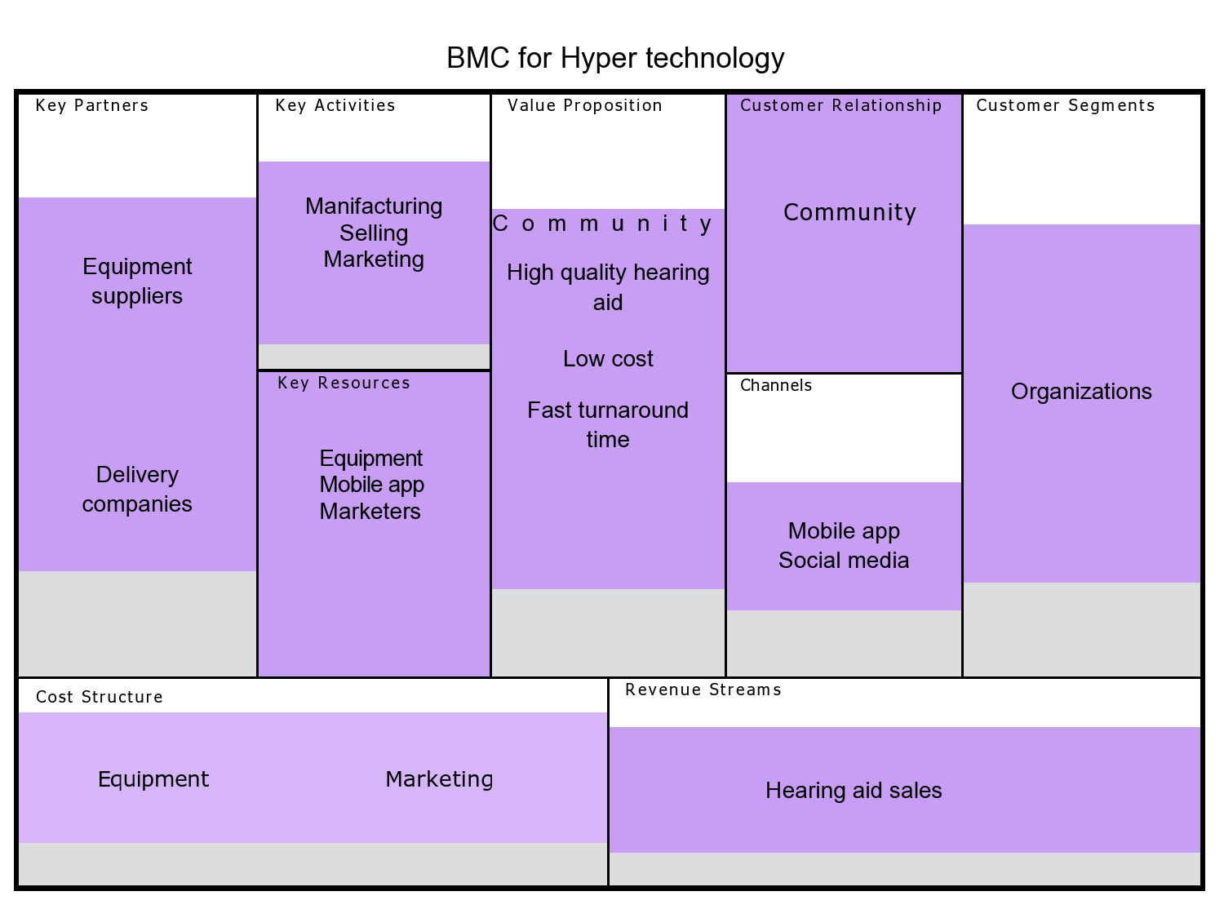

Contact us

Hanna Nabil

hananabilabd@gmail.com

Amr Ashour

Elmatator.itachi@yahoo.com

